VIDEO CALLING WEB APP USING PHP

INTERNSHIP REPORT

*Submitted by*

PATEL PARTH AKSHAYBHAI

201250107006

BACHELOR OF ENGINEERING

In

Computer Engineering

SHREE SWAMINARAYAN INSTITUTE OF TECHNOLOGY, BHAT

 

Gujarat Technological University, Ahmedabad

August, 2023

 

**SHREE SWAMINARAYAN INSTITUTE OF TECHNOLOGY, BHAT**

Gandhinagar - Ahmedabad Rd, Near EDI & Sardar Patel Ring Road Circle

, GIDC Bhat, Bhat, Gandhinagar, Gujarat 382428

# CERTIFICATE

This is to certify that the internship report entitled **“VIDEO** **CALLING WEB APP”** has been carried out by **Patel Parth Akshayhbhai** under my guidance in **Computer Engineering**, 7th Semester of Gujarat Technological University, Ahmedabad during the academic year 2023-24.

**Prof. Anuradha Tiwari Prof. Darshan Patel**

Internal Guide Head of Department

Computer Engineering Computer Engineering

SSIT, Bhat, Gandhinagar SSIT, Bhat, Gandhinagar

# COMPANY CERTIFICATE

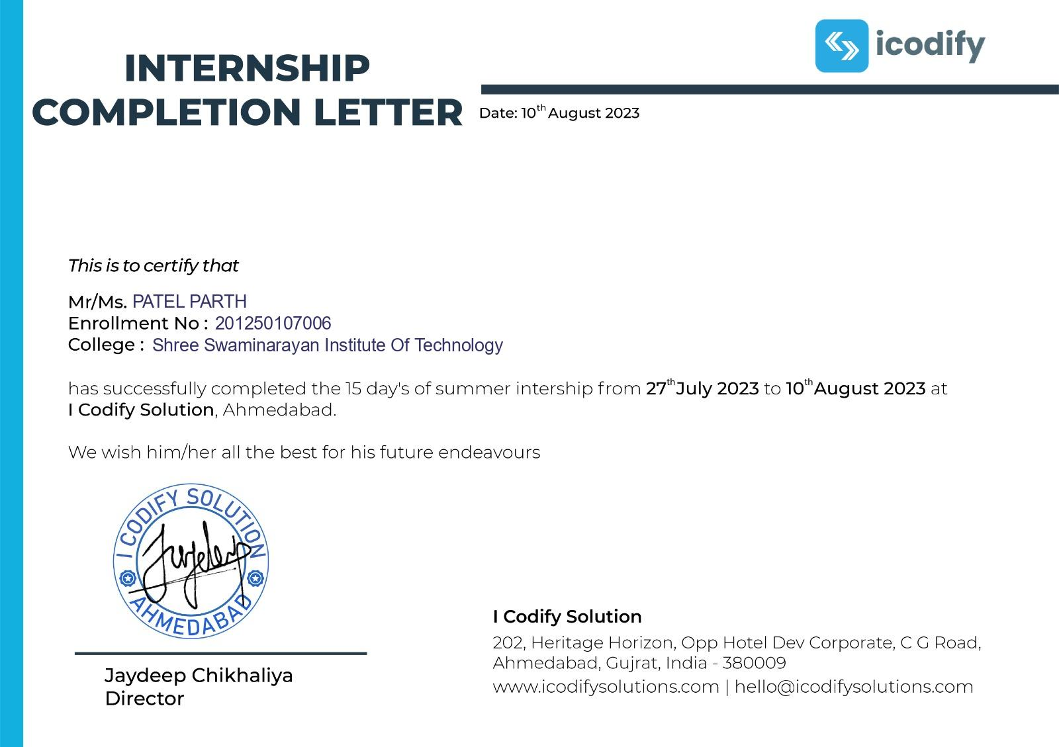

# 

# ACKNOWLEDGEMENT

The successful completion of my summer internship named “PHP” stands on the constant encouragement, guidance, and support, both technical & personal of many individuals.

However, it would not have been possible without the kind support and help of many individuals and institutional. We would like to extend our sincere thanks to all of them. We are highly indebted to our internal guide **Prof. Anuradha Tiwari**  for their guidance and constant supervision as well as for providing necessary support in the summer internship. This project work could not have been completed without the expert guidance **Prof. Anuradha Tiwari** who shown me proper path and direction of work.

They opened for me the offer of knowledge from repository of their experience. They have been encouraging me throughout my project work which increased my confidence and gave me the strength of working hard to achieve my target in time. This has impelled me to express my sincere gratitude to my project coordinator **Harsh Rupani** sir.

At the same time, I would like to thank my Head of the Department **Prof. Darshan Patel** for his kind cooperation and support. I would also appreciate his keen interest I helping me and his regular guidance throughout the project. I would also like to thank all the staff members of my department for their cooperation and help me when asked for. I am also grateful to all my colleagues for helping me with all their resources and knowledge they could, as when required.

PATEL PARTH

201250107006

# ABSTRACT

In today’s digital age, video calling has become an integral part of our communication landscape. This abstract outlines the development of a web-based video calling web application using PHP, a widely used server-side scripting language. The primary goal of this web application is to provide users with a seamless and secure platform for realtime video communication.

This video calling web application offers a reliable and accessible solution for users to connect with their friends, family, and colleagues effortlessly. The seamless integration of features ensures an engaging and user-friendly experience, making it a valuable tool for modern communication needs.

# TABLE OF CONTENT

1. **Acknowledgement .................................................................................................... i**
2. **Abstract.................................................................................................................... ii**
3. **Table of Contents.................................................................................................... iii**

**Chapter 1 Introduction…………………………………………...…………………. 7**

* 1. Project Summary……...………………………………………………………. 7
  2. Introduction of Laravel Framework…………………………………………... 8

**Chapter 2 About Technology…..……………………………………………………. 9**

* 1. HTML................................................................................................................. 9
  2. CSS..................................................................................................................... 9
  3. JavaScript ........................................................................................................... 9
  4. PHP…….............................................................................................................. 9
  5. Why Use PHP? ….............................................................................................. 10
  6. Features of PHP……......................................................................................... 10

**Chapter 3 System Requirement and Specification……………………...………… 11**

3.1 Software Requirements...................................................................................... 11 3.2 Hardware Requirements.................................................................................... 11

**Chapter 4 Task/Project Screenshot With Code….……………………...………… 12**

* 1. Task-1………………………………………………………………………… 12
  2. Task-2………………………………………………………………………… 13
  3. Task-3………………………………………………………………………… 16
  4. Task-4………………………………………………………………………… 18
  5. Task-5………………………………………………………………………… 224.6 Task-6………………………………………………………………………… 24

**Chapter 5 Conclusion……………………………………………………………… 29**

# 

# 

# 

# Chapter : 1

# INTRODUCTION

For newly introduced subject “summer internship (3170001)” by GTU. I joined one well noted Ahmedabad based it company named **“I Codify Solutions”** to learn **“PHP”** from scratch. The duration of the internship was about 15 days. In this time interval, I learned a technical thing regarding PHP with tools and technologies such as HTML, CSS and JAVASCRIPT etc.

With abstract of project is **Video Calling Web Application.**

In the point of fact, I got the benefit of having brilliant external guide as well as internal guide of my collage. I explored all the aspects of PHP framework in detail as well as I got the chance my existing knowledge for brush up the skills in HTML, CSS, JAVASCRIPT as long as in web development for the view of the fact that our project abstract.

**1.1 Project Summary**

The Video Calling Web Application project aims to develop a user-friendly and secure platform for real-time video communication over the internet.

This application will provide individuals and businesses with a reliable tool to conduct virtual meetings, conferences, interviews, and social interactions seamlessly.

**1.2 Introduction of Laravel Framework**

Laravel is a popular and open-source PHP web application framework known for its elegant syntax, robust features, and developer-friendly tools. It was created by Taylor Otwell and was first released in 2011. Laravel is designed to simplify and accelerate the development of web applications, making it a preferred choice for developers.

Laravel is a popular PHP web application framework known for its developer-friendly features and elegant syntax.

Features of Laravel :

* Elegant Syntax
* MVC Architecture
* Middleware
* Validation
* Testing
* Security Features
* API Development
* File Storage and Cloud Integration

# Chapter : 2

# ABOUT TECHNOLOGY

**2.1 HTML**

HTML, which stands for HyperText Markup Language, is the standard markup language used to create web pages and structure the content on the World Wide Web. HTML provides a set of elements or tags that are used to define the structure and content of a web page.

**2.2 CSS**

CSS, which stands for Cascading Style Sheets, is a fundamental technology used in web development to control the presentation and styling of HTML documents. It enables web developers to define how web pages should look and how their content should be displayed to users.

**2.3 JavaScript**

JavaScript is a versatile and widely-used programming language that plays a crucial role in web development and beyond. It's known for its ability to add interactivity, manipulate web page content, and create dynamic web applications.

**2.4 PHP**

PHP (Hypertext Preprocessor) is a widely-used server-side scripting language designed for web development. It enables the creation of dynamic web pages by embedding PHP code within HTML. PHP is known for its ease of use and versatility, making it a popular choice for web developers. It can interact with databases, handle form data, generate dynamic content, and perform various server-side tasks.

**2.5 Why Use PHP?**

PHP is a versatile and widely adopted scripting language with a robust ecosystem, making it a strong choice for web development, especially for creating dynamic web applications, content-driven websites, and e-commerce platforms. Its simplicity, performance improvements, and integration capabilities continue to make it a relevant and popular choice among developers.

There are several compelling reasons to use PHP for web development:

* Ease of Learning and Use
* Database Integration
* Cross-Platform Compatibility
* Extensive Library and Framework Support
* Performance
* Community and Ecosystem
* Scalability
* Cost-Effectiveness

**2.6 Features of PHP**

* Open Source
* Server-Side Scripting
* Security
* Regular Expressions
* File Handling
* Error Handling
* Command-Line Scripting
* Vast Community

## Chapter : 3

**SYSTEM REQUIREMENT AND SPECIFICATIONS**

**3.1 Software Requirement:**

|  |  |  |
| --- | --- | --- |
| **Operating System** | **Languages** | **Web Server** |
| Windows 7 | HTML  CSS  JavaScript  PHP | Browsers(Chrome,  Firefox, etc.) |

**3.2 Hardware Requirements:**

|  |  |  |
| --- | --- | --- |
| **Processor** | **Memory Requirement** | **Hard Disk** |
| Intel Core i3 | 4GB RAM | 256GB |

# Chapter : 4

# TASK/PROJECT SCREENSHOT WITH CODE

**4.1 Task-1** Swap Numbers Using PHP

In Fifteen day Summer Internship first of all we grabed the knowledge about PHP and their Functions and then second day of our internship performed some basic programs/logics in PHP.

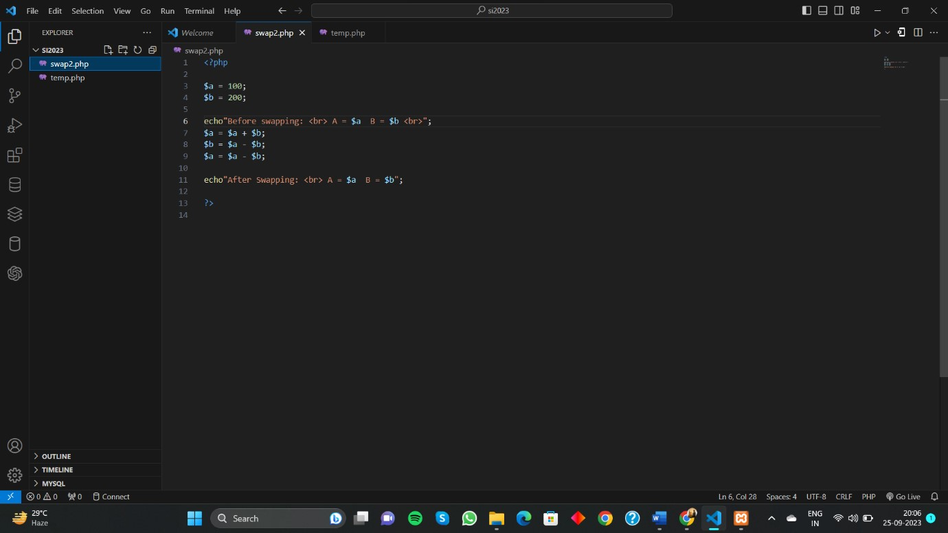

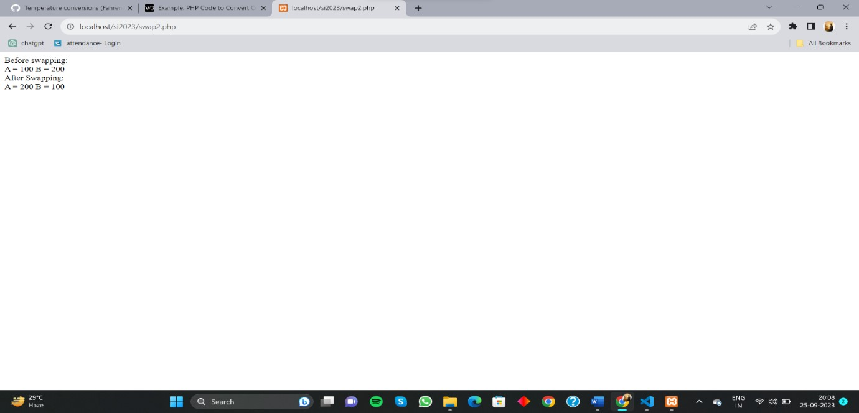

**4.2 Task-2** Temperature Converter Using PHP

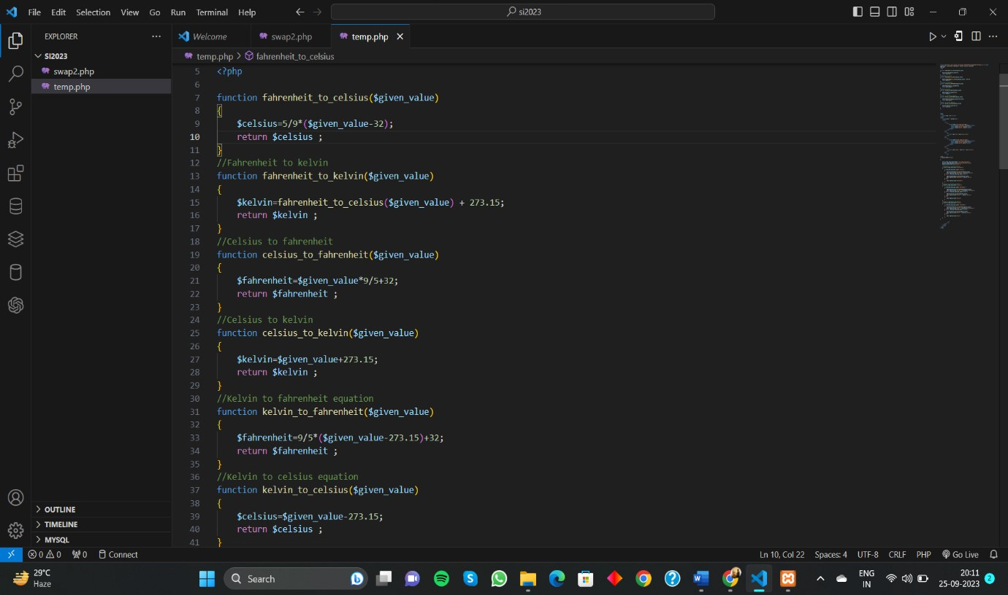

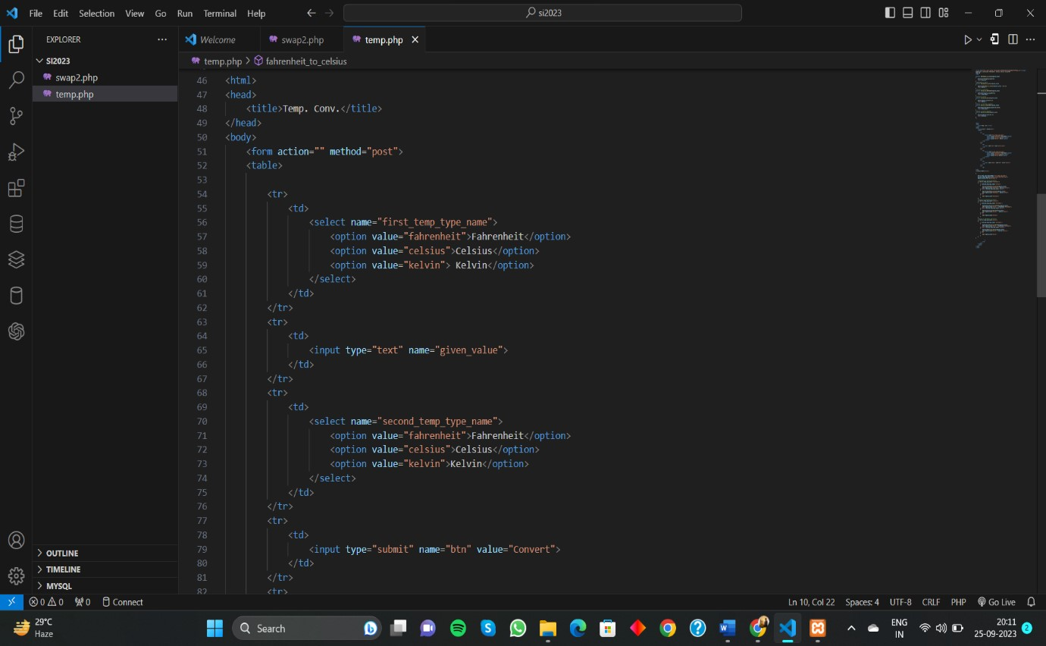

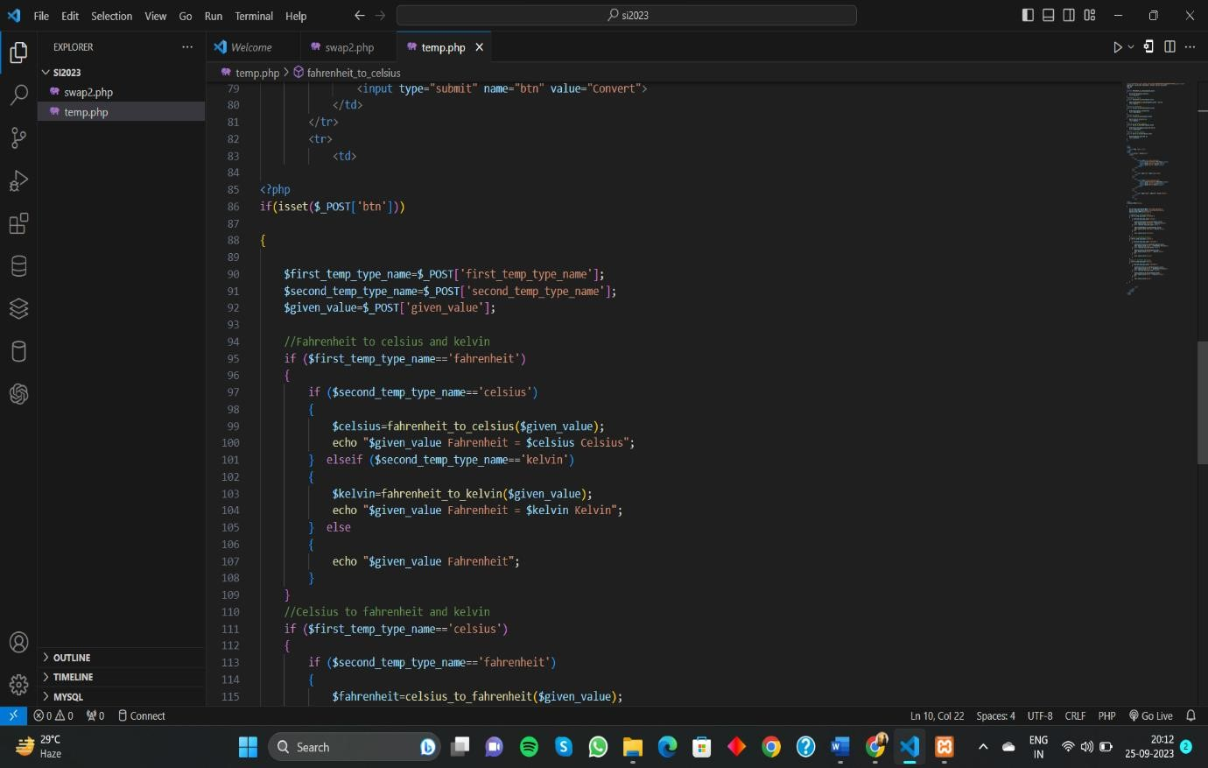

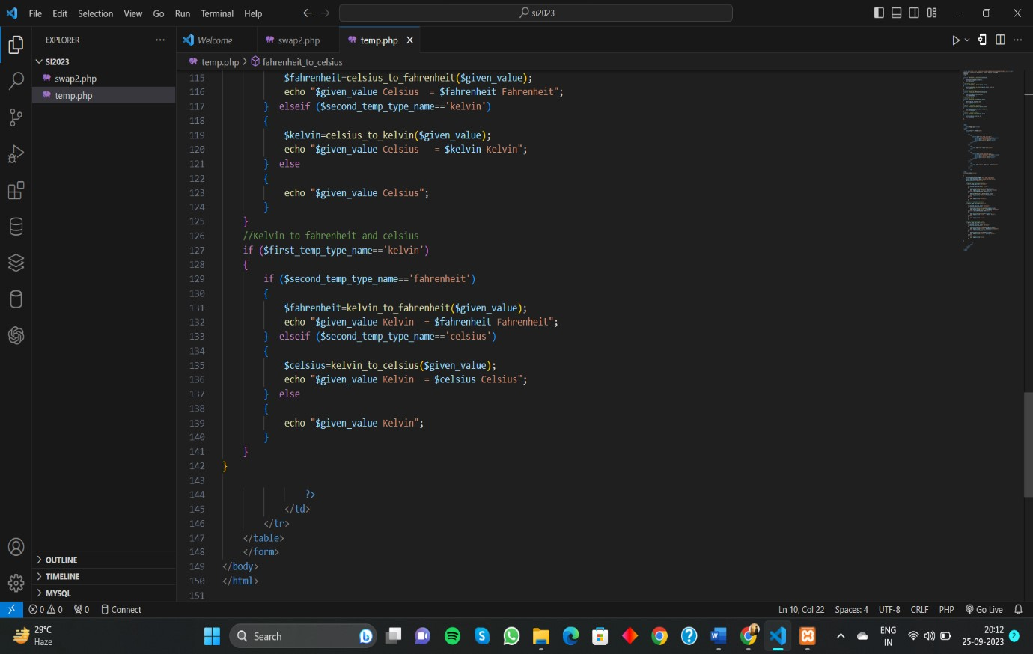

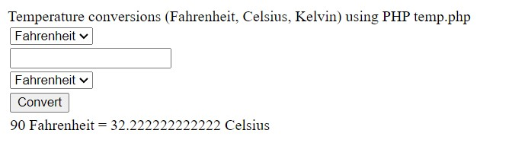

**4.3 Task-3** Find The Area Of Shapes

1. Area of Rectangle **:**

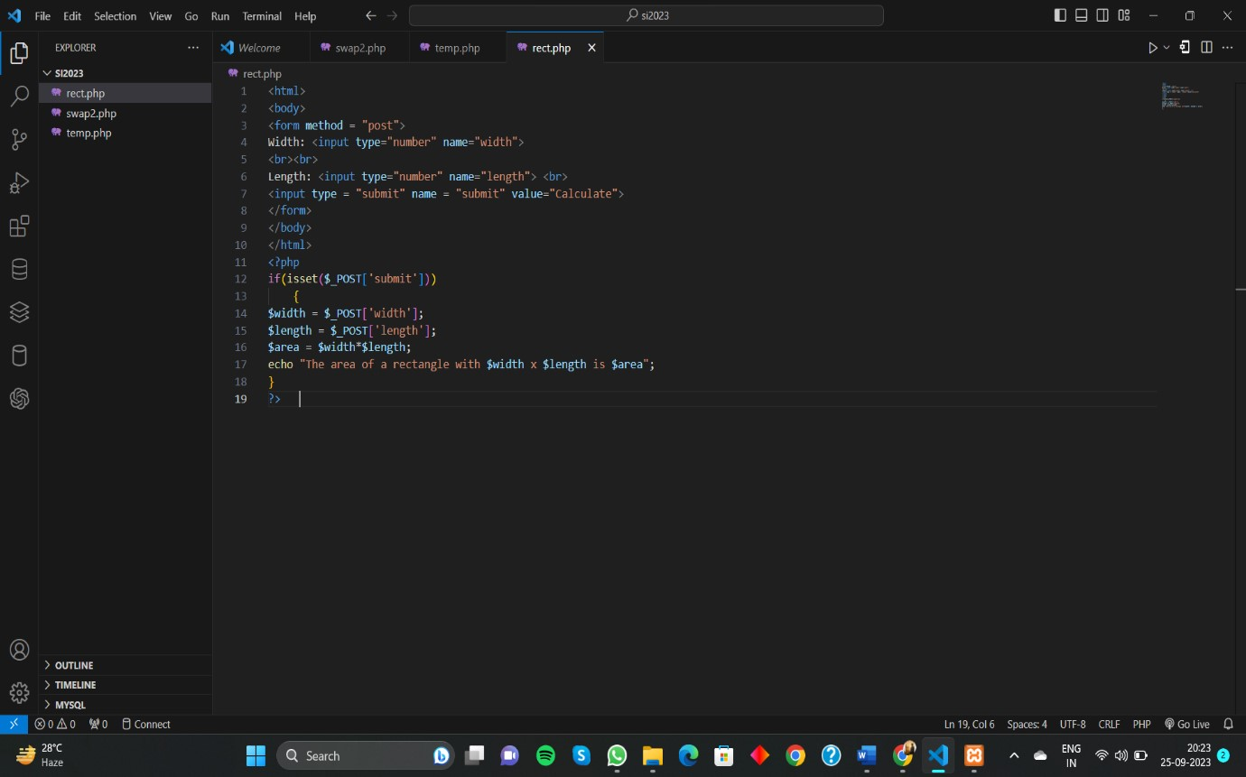

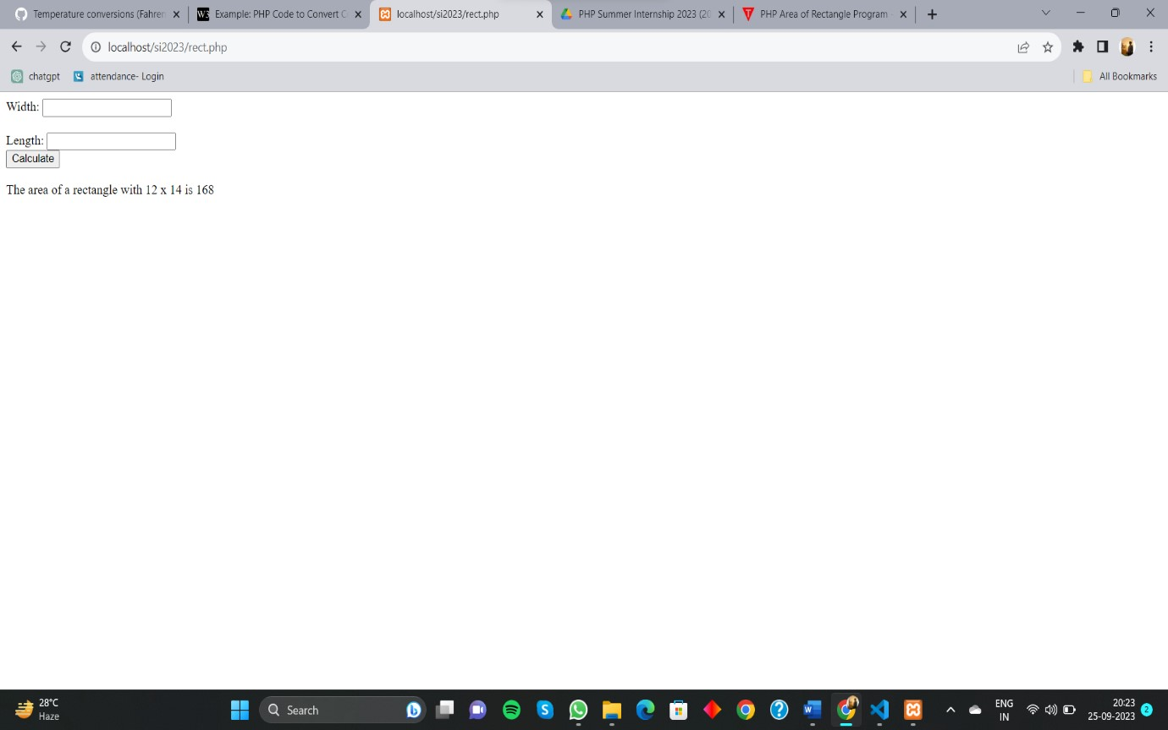

1. Area of Square, Pentagonal, Hexagonal :

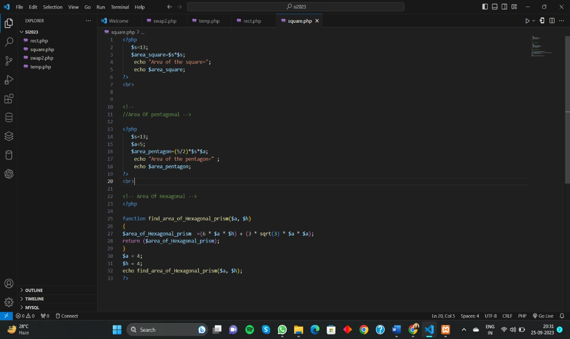

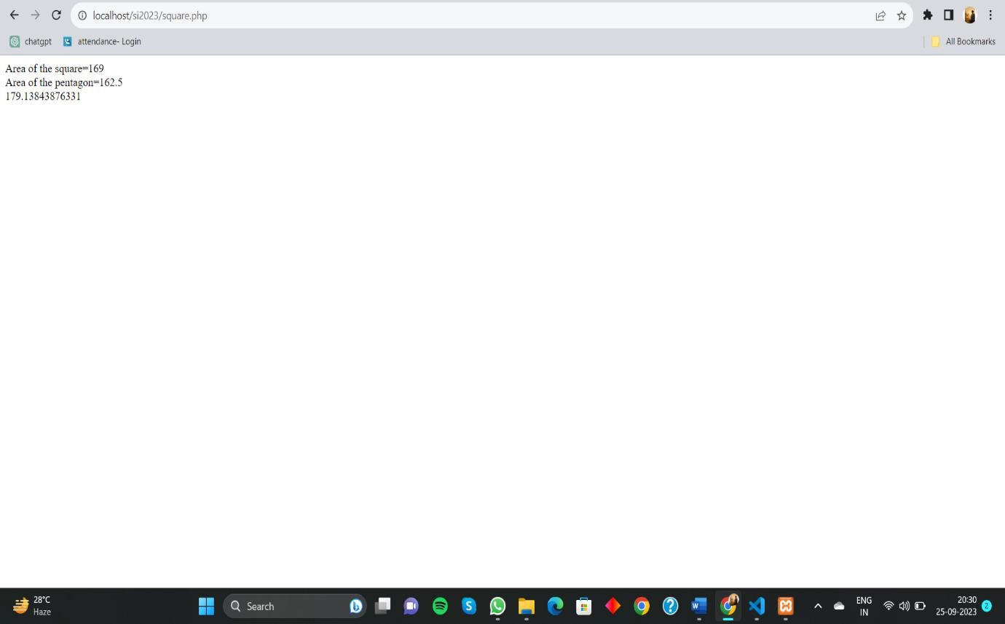

**4.4 Task-4**

In this Internship we learned how to send E-mail or Attachment using Composer and Packagist in PHP.

Composer and Packagist have significantly improved the PHP development experience by simplifying dependency management and making it easier to share and reuse code across projects.

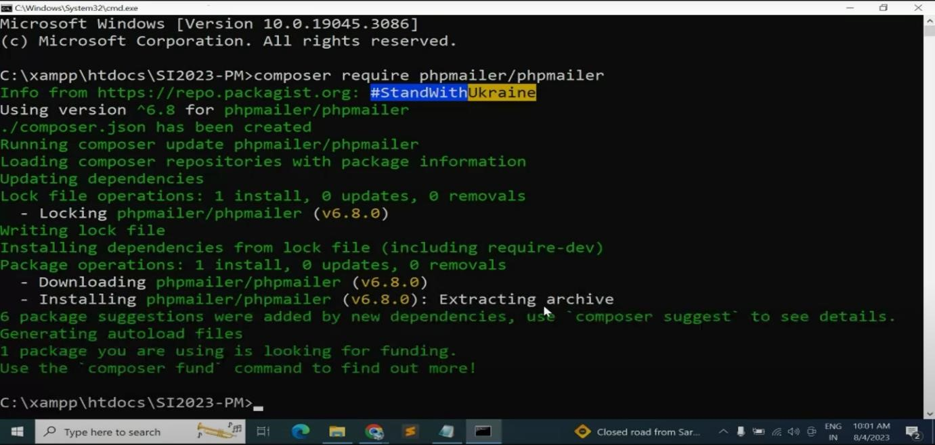

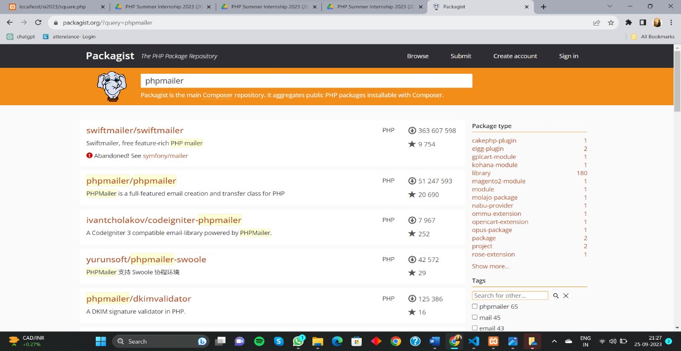

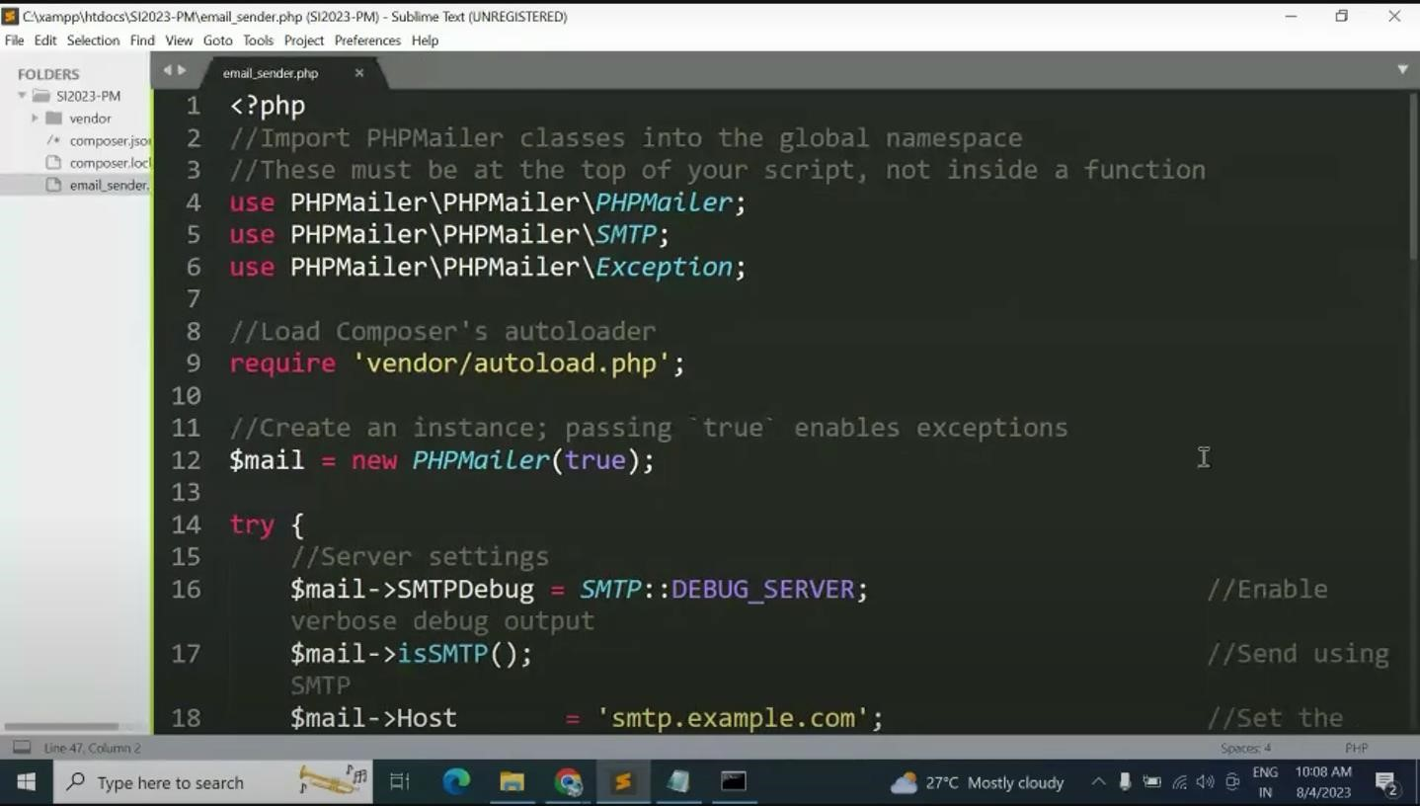

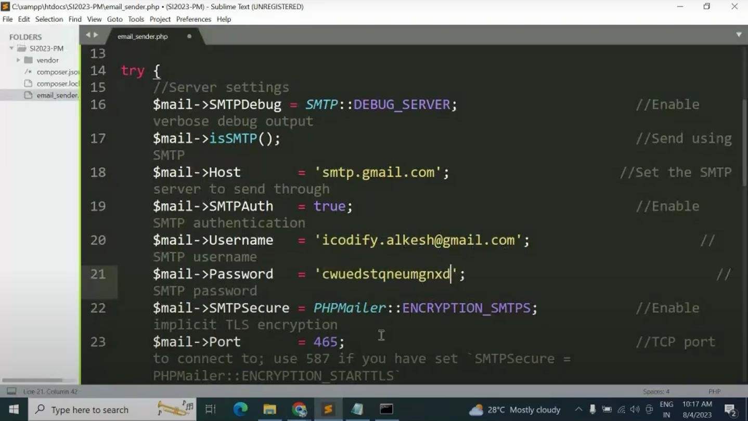

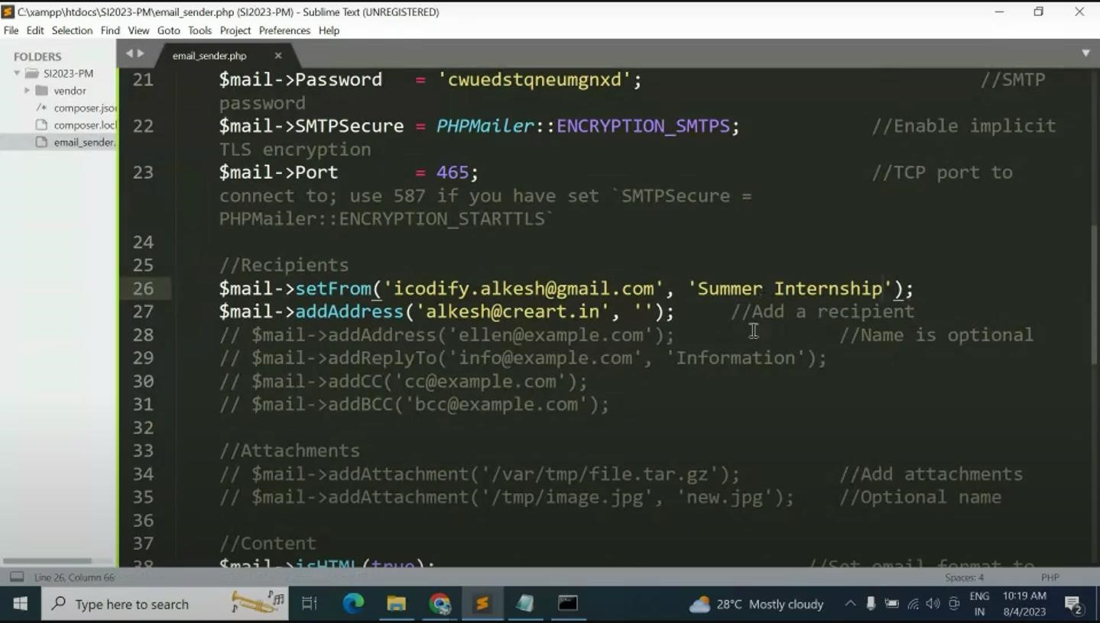

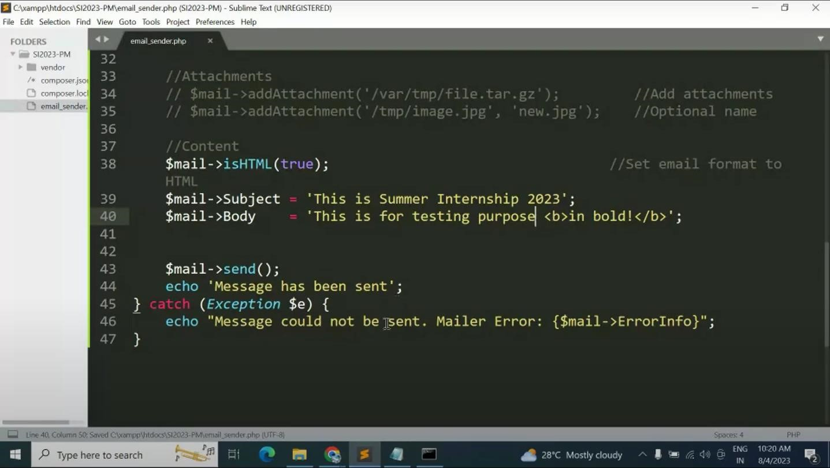

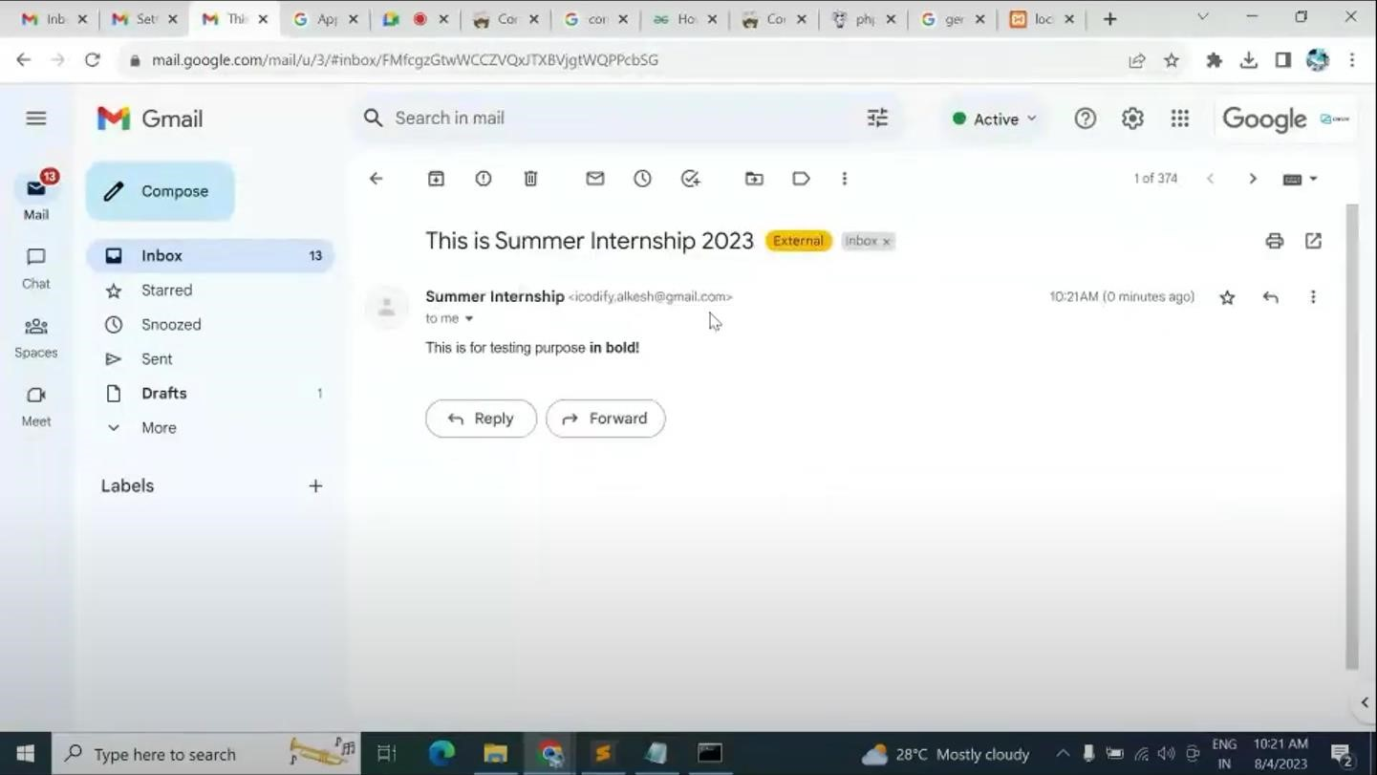

* 1. **Task-5** Create Channel ID and Secret Key in Scaledrone.

Scaledrone is a cloud-based real-time messaging service that provides the infrastructure and tools for developers to easily implement real-time functionality in their applications. It is commonly used to enable features such as chat, live updates, notifications, and collaborative editing in web and mobile applications.

It simplifies the process of adding real-time capabilities to applications, which can be particularly valuable for building interactive and collaborative features.

Using scaledrone we made the Channel Id and Secret Key for our project and we was put that Channel Id in our project’s source code for real time updates and notifications.

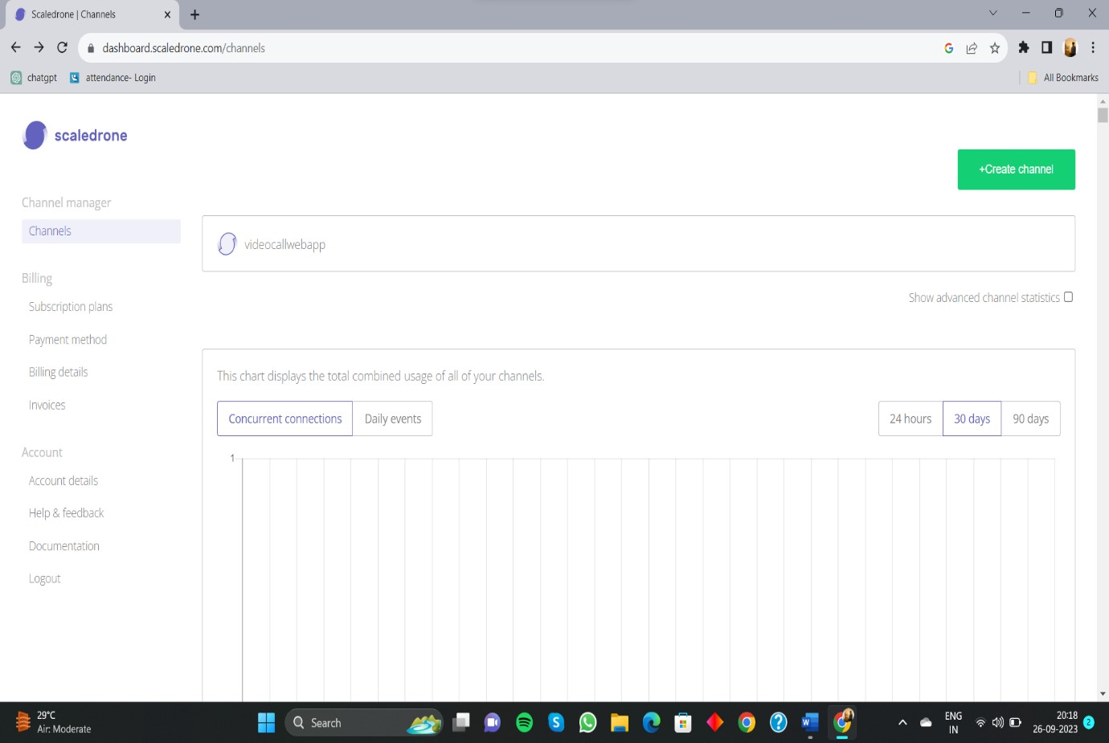

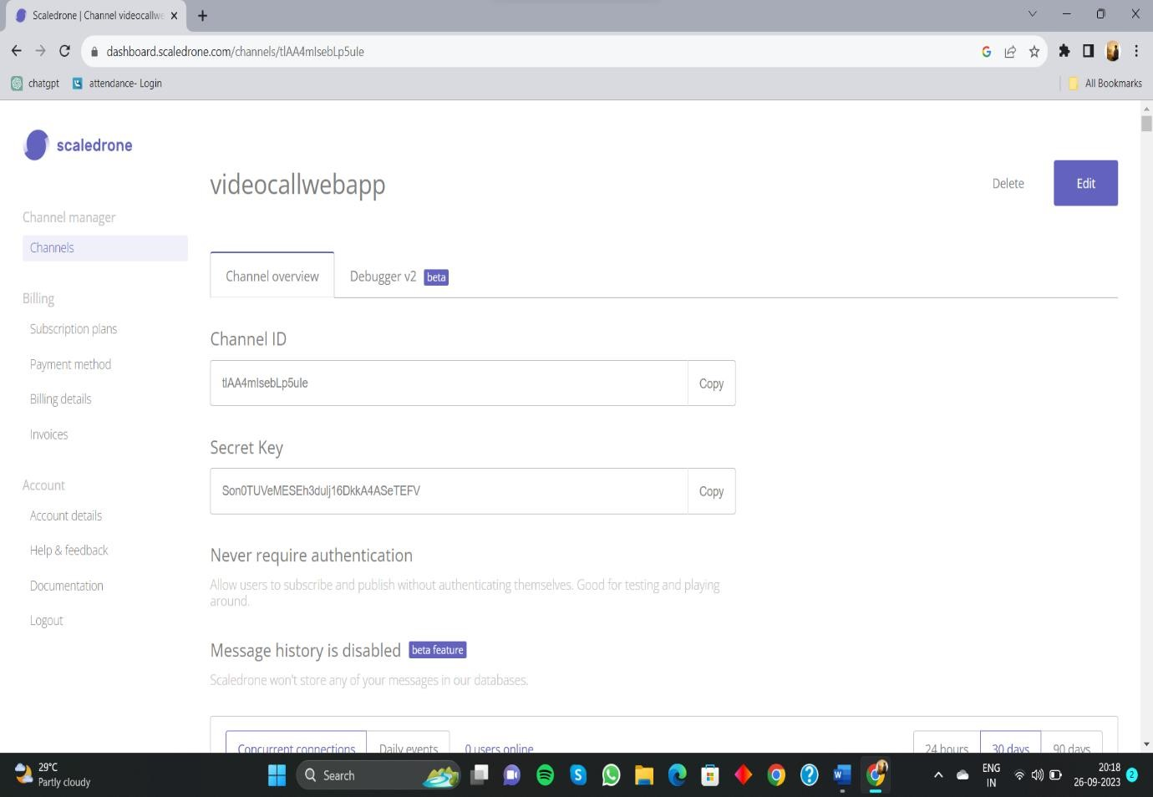

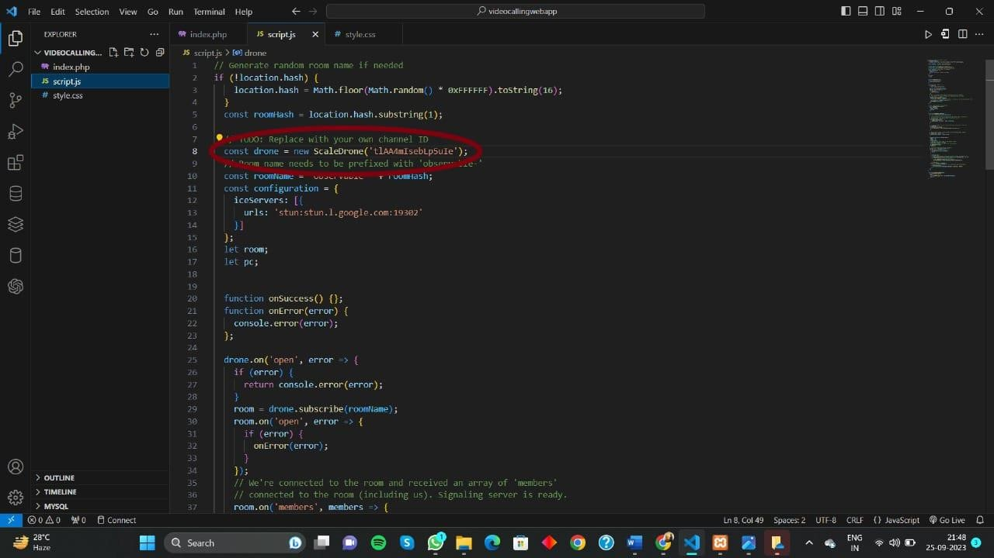

* 1. **Task-6**  Video Calling Web Application

**Source Code:**

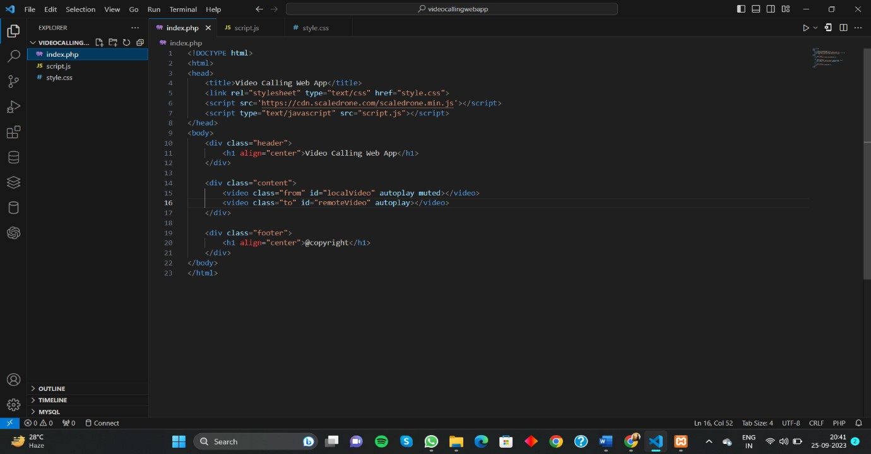

**Fig.1 HTML Code**

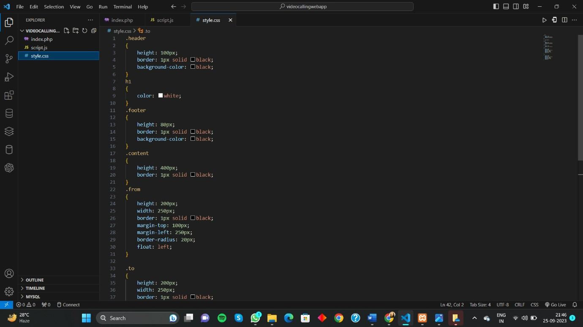

**Fig.2 CSS Code(1)**

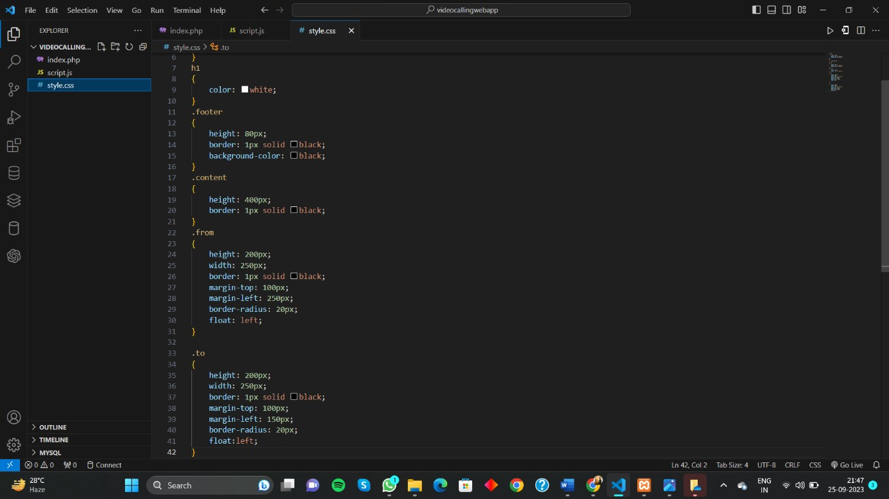

**Fig.3 CSS Code(2)**

**OUTPUT(1):**

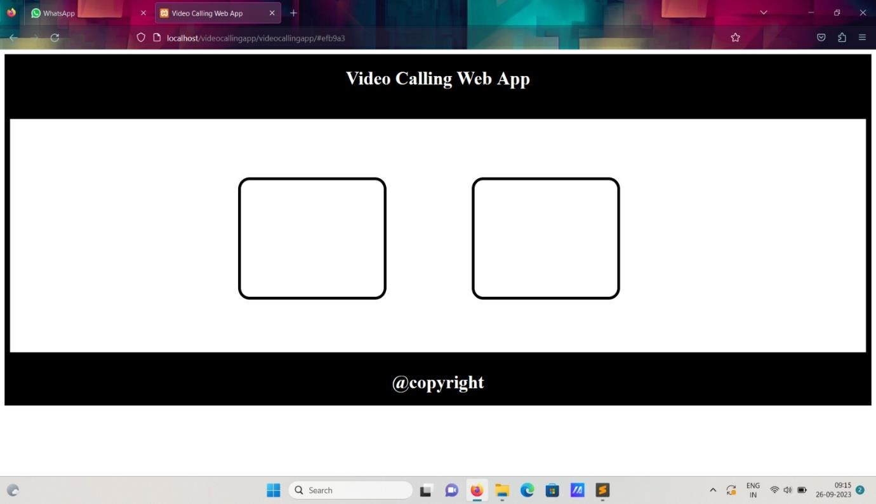

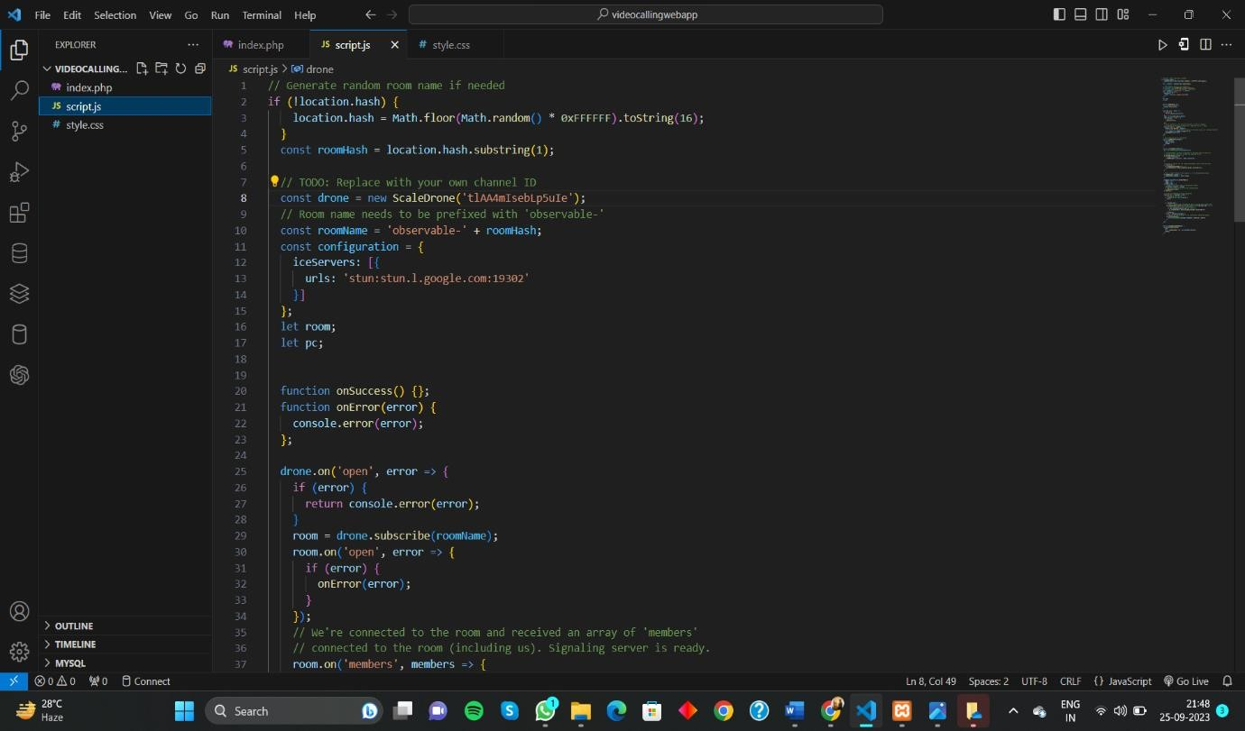

**Fig.4 JS Code(1)**

**Fig.5 JS Code(2)**

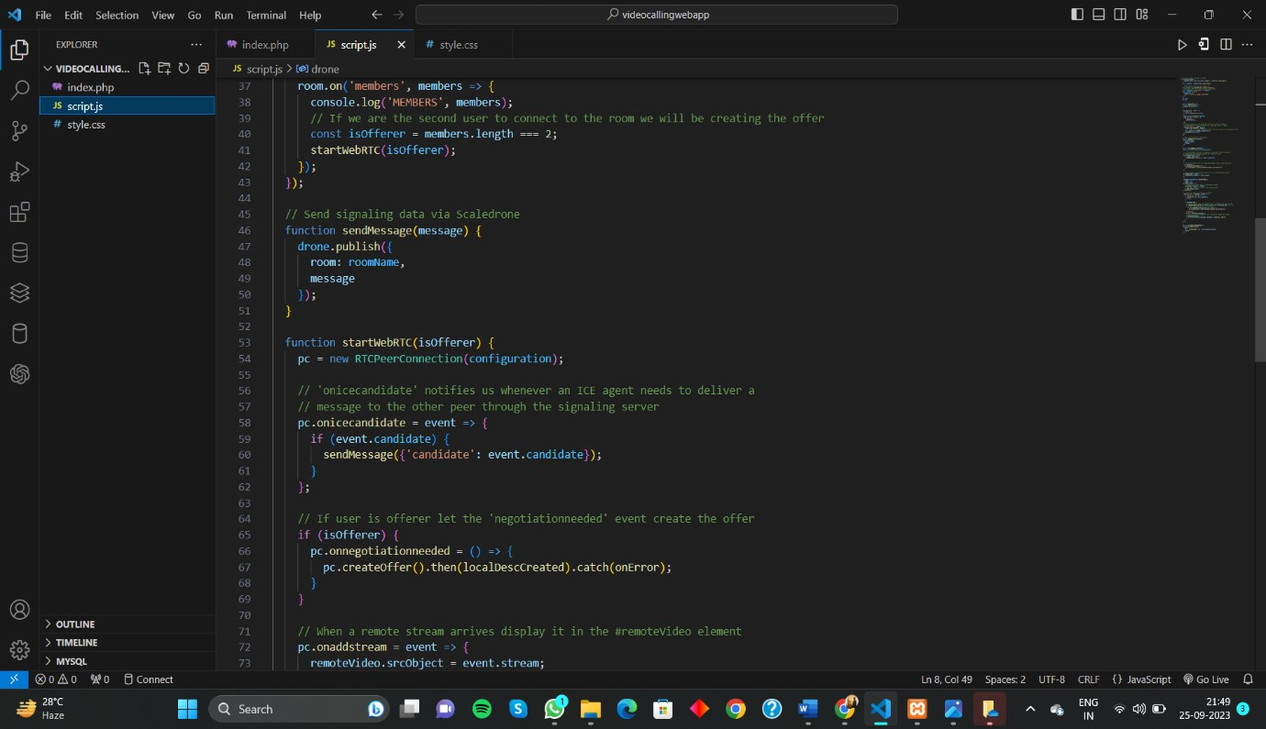

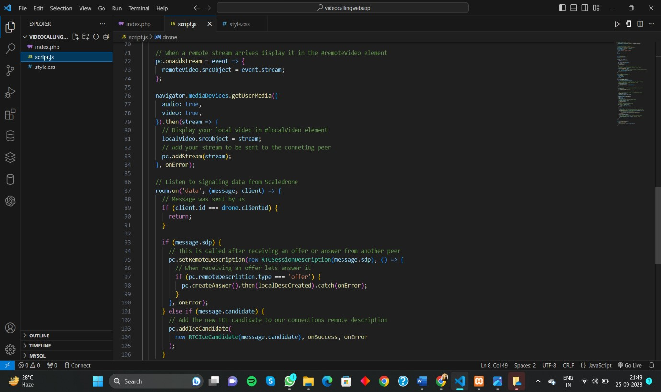

**Fig.6 JS Code(3)**

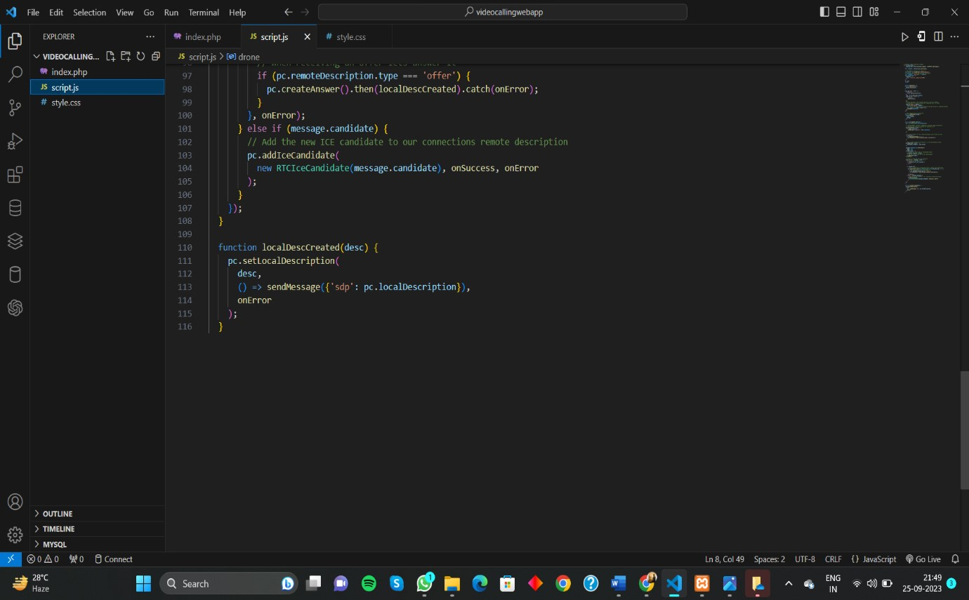

**Fig.7 JS Code(4)**

**OUTPUT(2):**

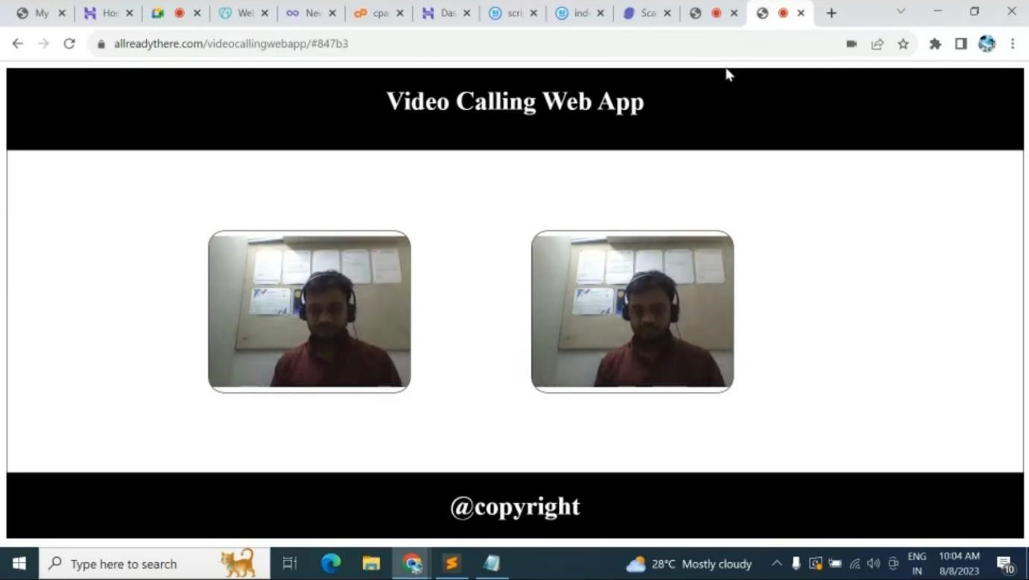

## Chapter : 5

## Conclusion

## 

In conclusion, creating a video calling web application using HTML, CSS, and JavaScript is a complex but achievable task. This type of application leverages the power of WebRTC (Web Real-Time Communication) to enable real-time video and audio communication between users through web browsers.

The essential components of such an app include HTML for structuring the user interface, CSS for styling, and JavaScript for controlling the behavior and interactions. Key functionalities involve capturing and streaming audio and video, setting up WebRTC connections, and managing signaling between users.

Building a video calling web app also requires a signaling server to facilitate communication between users. This server helps exchange essential session information, such as session descriptions and ICE candidates, making it possible to establish peer-to-peer connections.

Overall, creating a video calling web app demands careful consideration of UI/UX design, WebRTC implementation, signaling server setup, and thorough testing for compatibility and performance across different browsers. With the right tools, libraries, and attention to detail, developers can create a robust and functional video calling web application.

**THANK YOU**